

**DOCUMENTATION**

*For*

**E-Project**

*Starting with the Name Of Allah, The Most Kind, The Most Merciful.*

Firstly, we would thank Allah, as for surely with His Grace and Mercy, we have succeeded in completing our task of e-project. We the students of batch 12B - 2020 are herby to present our e-project that was based on **(HTML, CSS & JAVASCRIPT).**

We were assigned to make a floral website named as ‘Blooming Petals’ with the help of **HTML, CSS & JAVASCRIPT**. We have used *Visual Studio Code* for coding and *Google* for all of our research work.

*“We earnestly hope that this project will provide all the necessary information required for the user to fulfill their requirement. However, suggestions for improvement of the project will be thankfully acknowledge”*



Certificate

of Completion

This is to certify that **Blooming Petals** using Windows form Technologies with

Visual Studio Code, HTML5, CSS3 and JavaScript

has been completed with all functionality by the students of

PM-202012B

____________________ ____________________

CEO Date



The Thirst of learning, up grading technical skills and applying the concepts in real life environment at a fast pace is what the industry demands from IT professionals Today. However busy work schedules, far-flung locations, unavailability of convenient time-slots pose as major barriers when it comes to applying the concepts into realism and hence the need to look out for alternative means of implementation in the form of laddered approach.

The above truly pose as constraints especially for our students too! With their busy schedules, it is indeed difficult for our students to keep up with the genuine and constant need for integrated application which can be seen live especially so in the field of **IT** education where technology can change on the spur of a moment. Well, technology does come to our rescue at such times!!

Keeping the above in mind and in tune with our constant Endeavour to use Technology in our training model, we at **APTECH** have thought of revolutionizing the way our students learn and implement the concepts using tools themselves by providing a live and synchronous **“CPSIM – E-Project”** learning environment!

**PREFACE**

First of all, we would like to thank **ALLAH** the almighty, who gave us mind to think and heart to feel creativity. Creation depends on thinking.

Secondly, before mentioning my team members and contributors of this project, I would like to thank our **Sir Asir** of APTECH who was us at all our stages and gave all possible guidance and techniques to overcome our difficulties.

Very special thanks to all our teachers who gave us valuable teaching and brilliant suggestion and always encourage us to do the best.

Surely, we would also like to express our deepest gratitude to our parents whose well wishes enabled us to transform our dreams into reality.

**Requirements**

**&**

**Specifications**

The Web site is to be created based on the following requirements.

**1)** The Home Page should be created with sections, graphics and with a suitable

logo.

**2)** Home Page should contain details of different flowers/floral decors with

suitable images.

**3)** The site should display a menu which will contain the options for brief

introduction about the various floral themes/decorations available, location of

the shop and any other information if required.

**4)** The information about products should be presented in two ways:

1. Information should be available category wise, wherein user can

click on a particular category and should be able to view all the

products related to the category available with complete

information. E.g. Category can be “Birthdays”, “Anniversaries”,

marriages” etc. with suitable sub-categories been defined.

*(b)* Information should be categorized according to the type of flowers

Like if a User wants to see only “Rose decors” or any other

particular flower products then he/she can click on a

Link/button/menu etc. and can see only that products.

**5)** When a user selects any particular flower, a list of products for that brand will

be displayed

**6)** A brief summary of individual products should be displayed on the Web Page

along with the product but detailed Features should be stored in Individual

Word documents which can be downloaded or viewed by the User who wishes

to see the same.

**7)** The user should also be able to compare the various products of different as

well as similar categories.

**8)** There should be a “Contact Us” page which will have the Address of the

Company with location should be displayed using Geo-Location API (eg.

Google Maps) and the mail address which when clicked will invoke the local

mail client from where they can send an email.

**Problem Statement**



“*Blooming Petals*” is selling various types of flowers and floral decorations. The

company advertises by distributing the pamphlets, advertising on television and so

on. Due to rapid development in internet field, the company decides to launch a

website where people will get all the information about the various products available

with them easily.

* **Hardware**
* A minimum computer system that will help you access all the tools in the

courses is a Pentium 166 or better

* 64 Megabytes of RAM or better
* **Software**
* Notepad/HTML editor
* Dreamweaver
* IE 5.0/ Netscape 6.0

**Homepage**

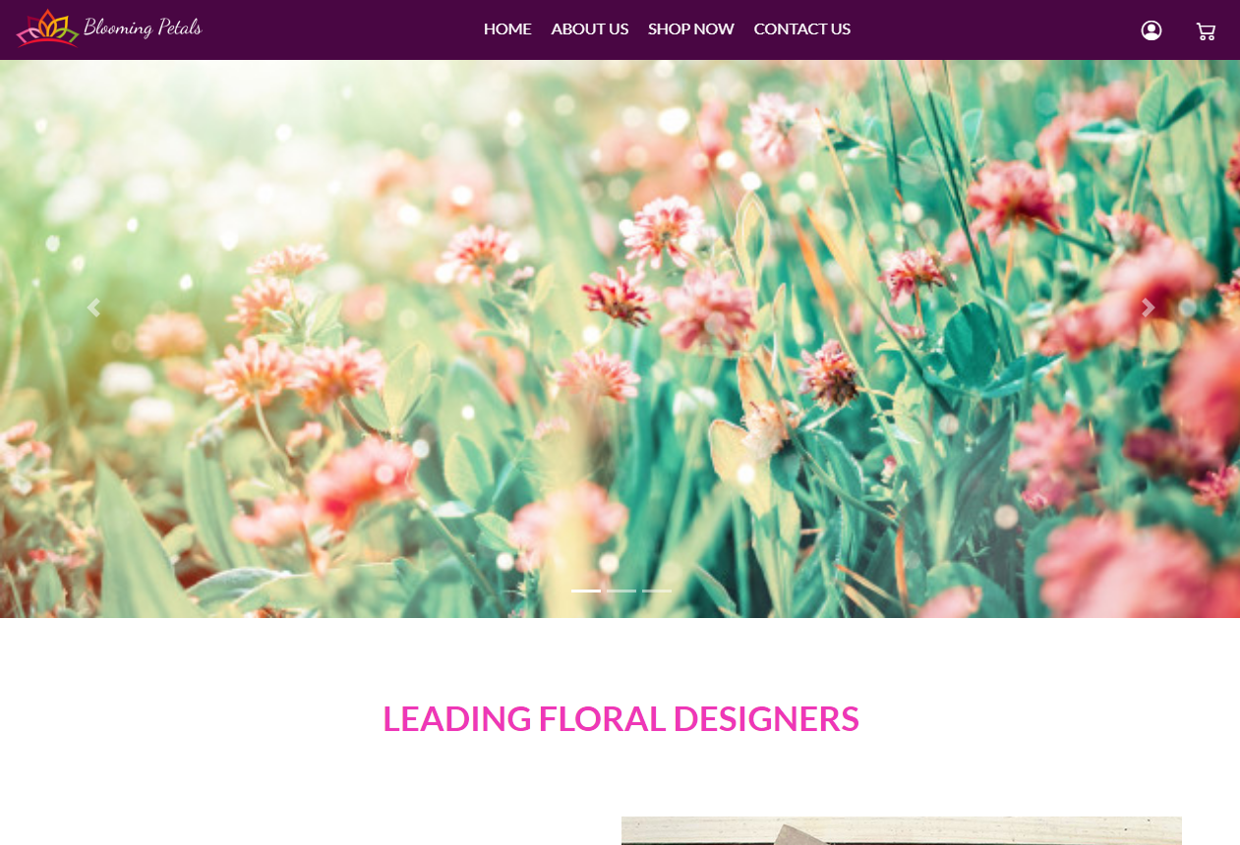

**About Us**

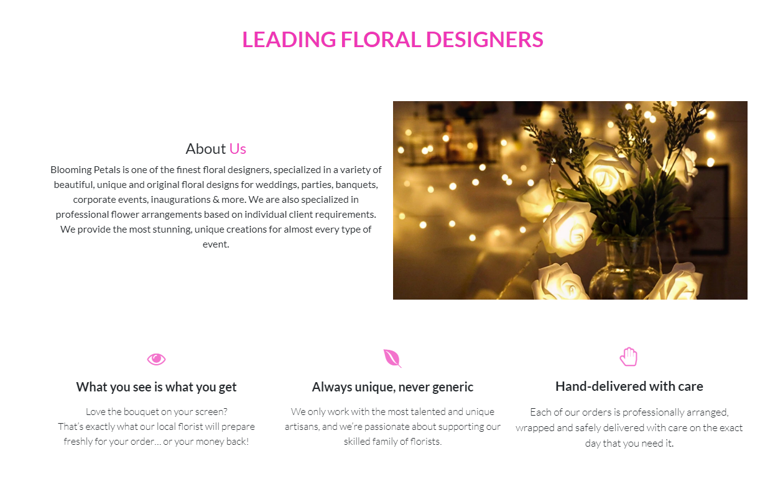

**Shop Now**

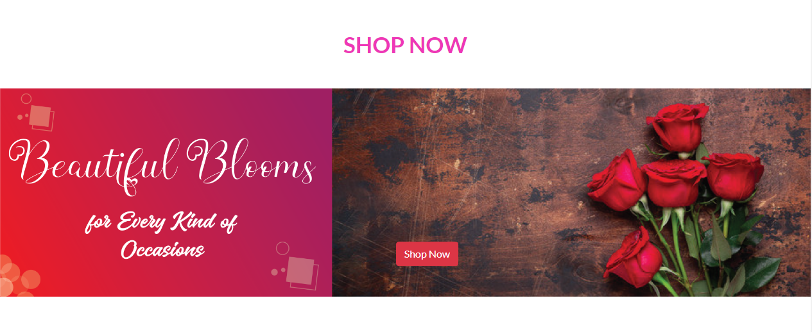

**Top Picks**

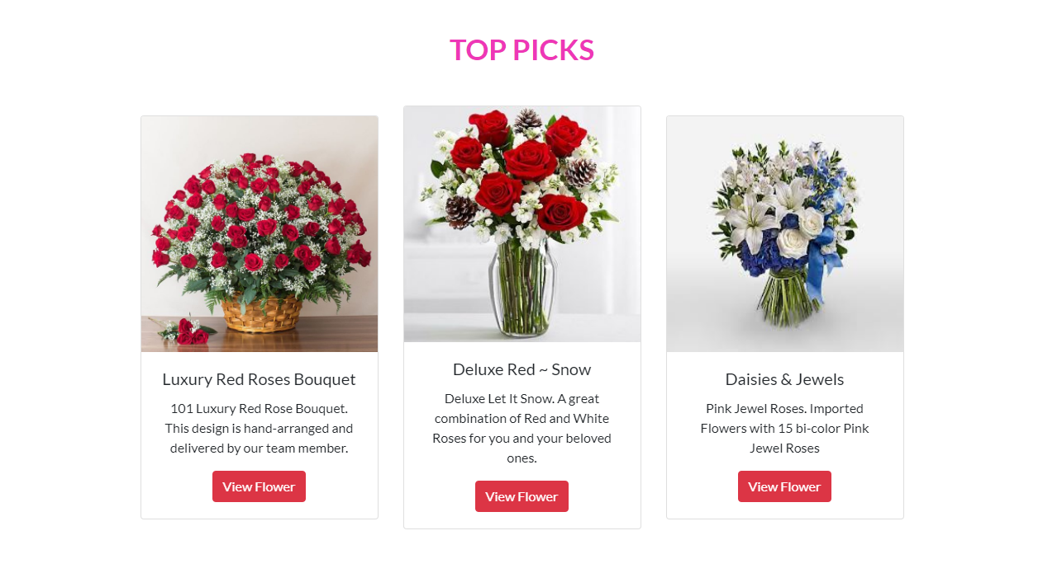

**Footer / Contact US**

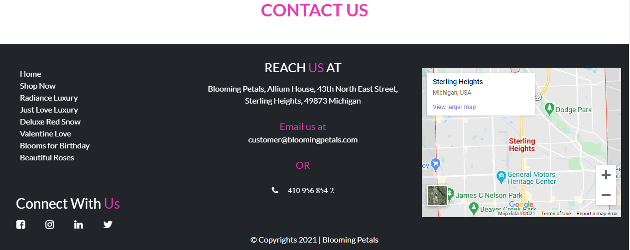

**Shop Now-In Page**

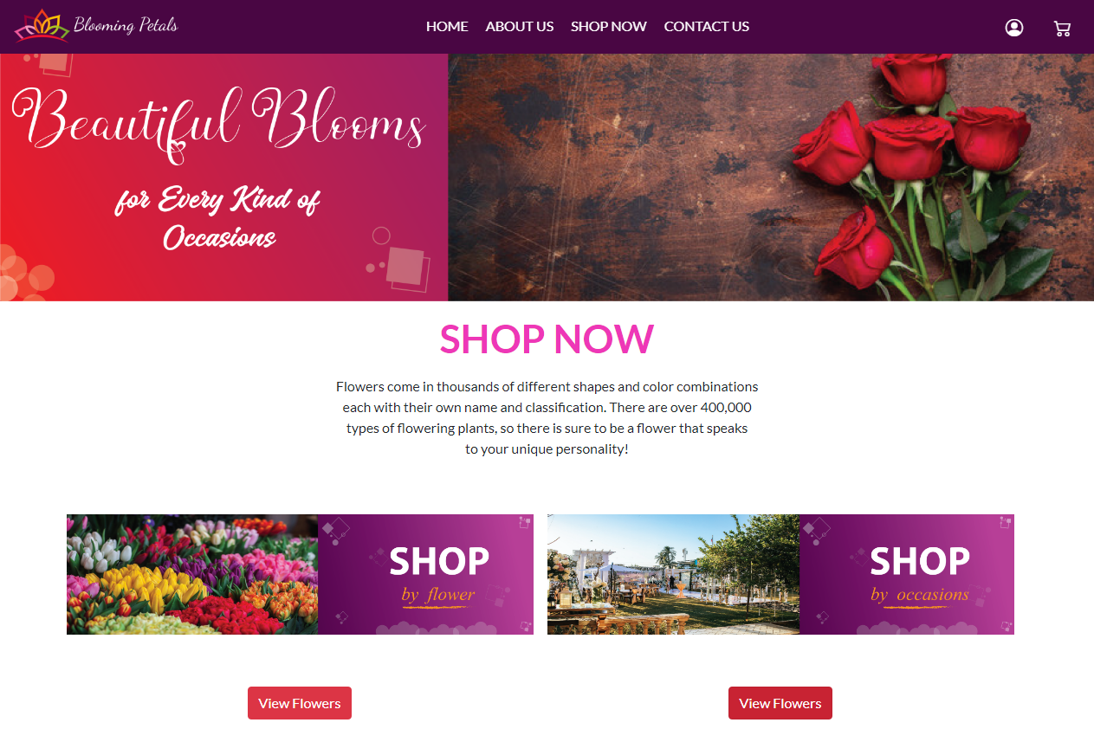

**SHOP**

***by Type / Flower***

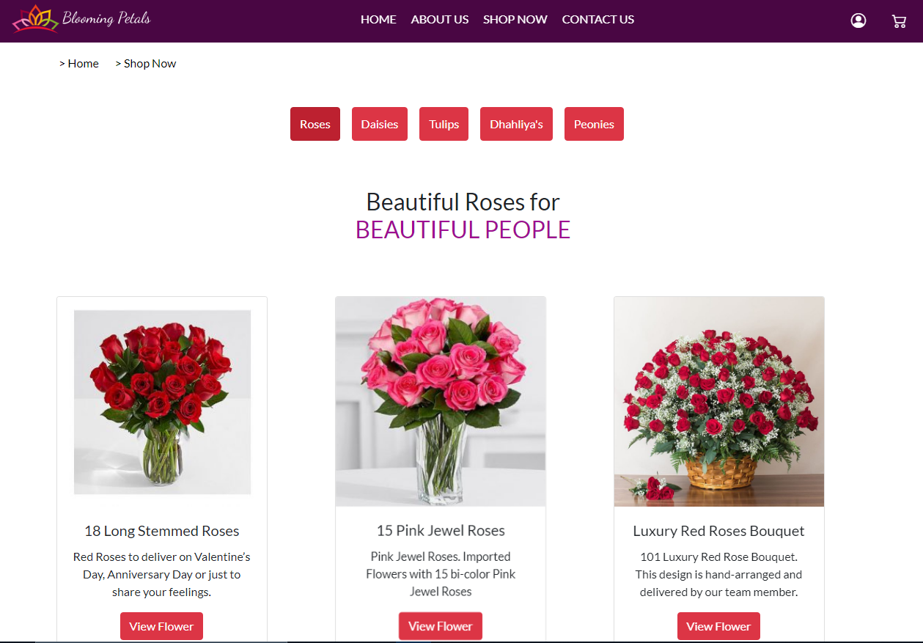

**SHOP**

***by Type / Flower***

***~ Categories***

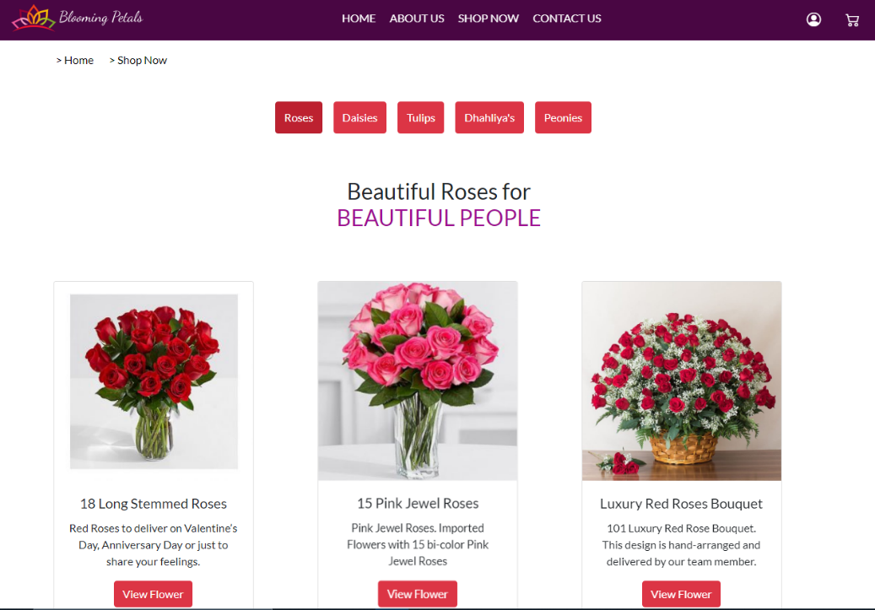

**Roses**

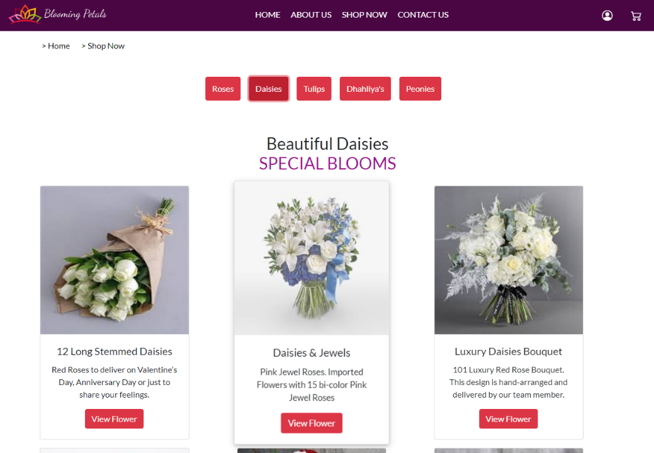

**Daisies**

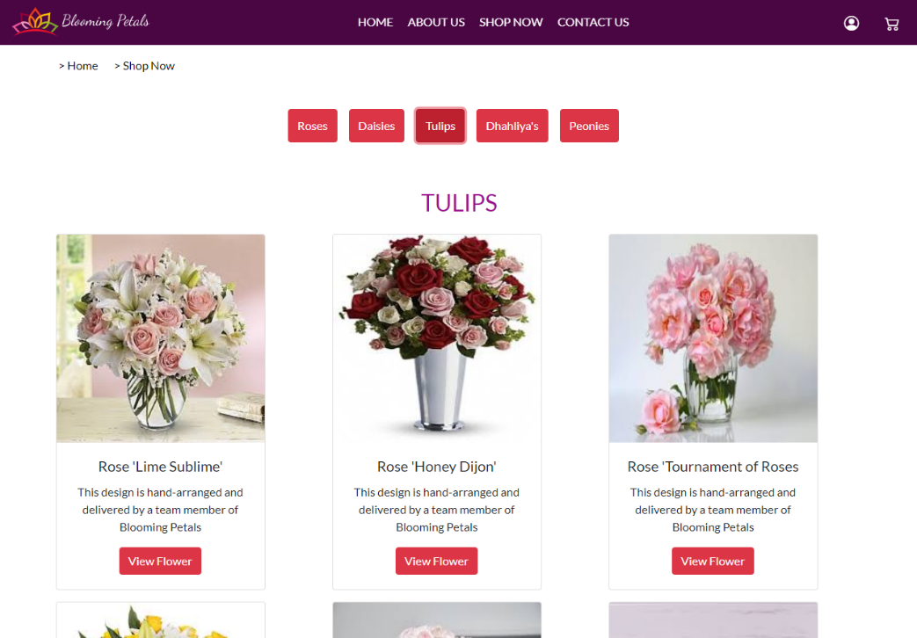

**Tulips**

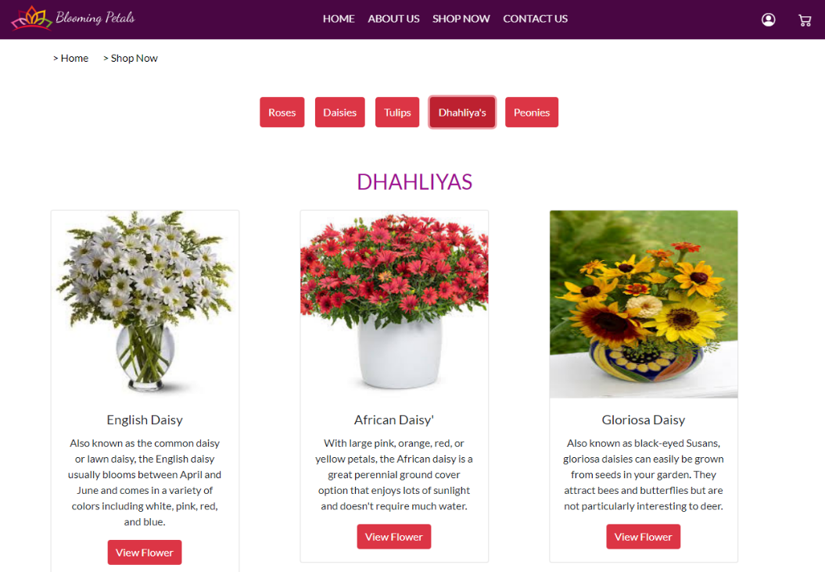

**Dhahliya**

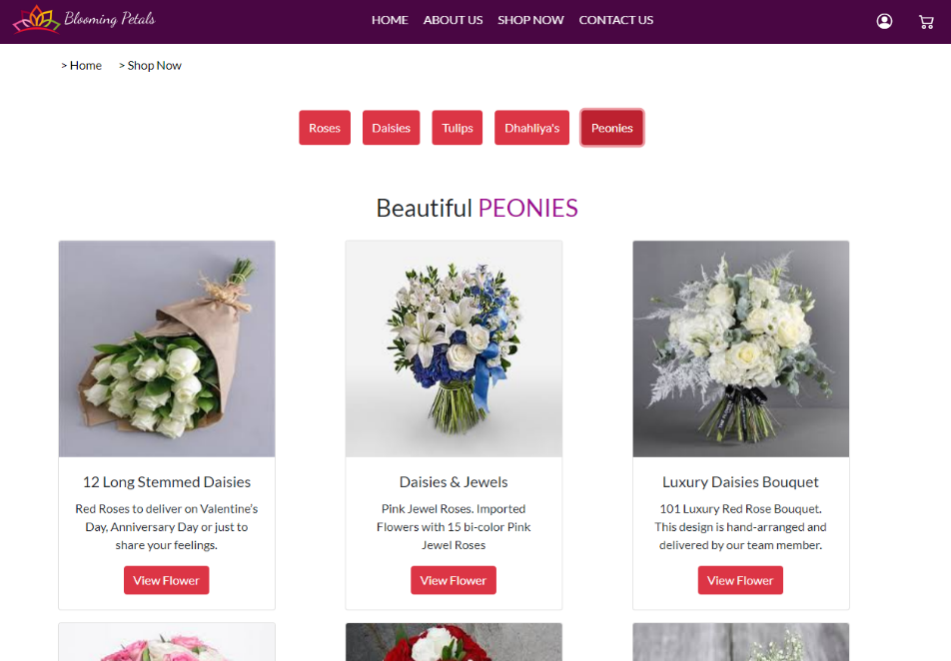

**Peonies**

**SHOP**

***by Occasions***

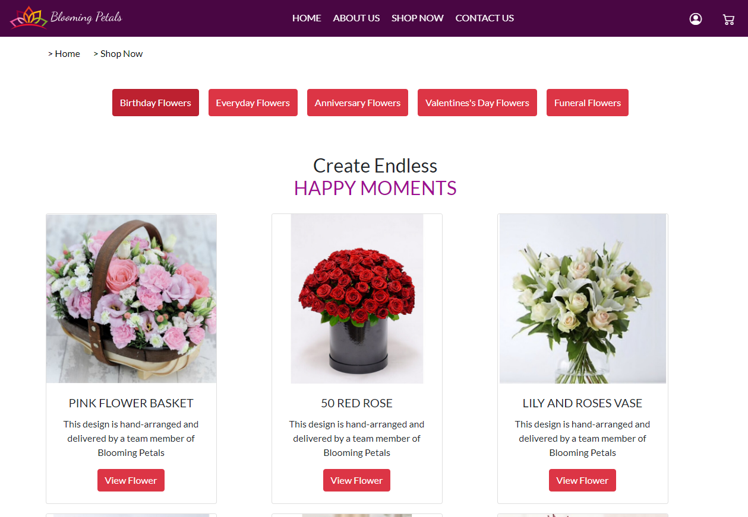

**SHOP**

***by Occasions***

***~ Categories***

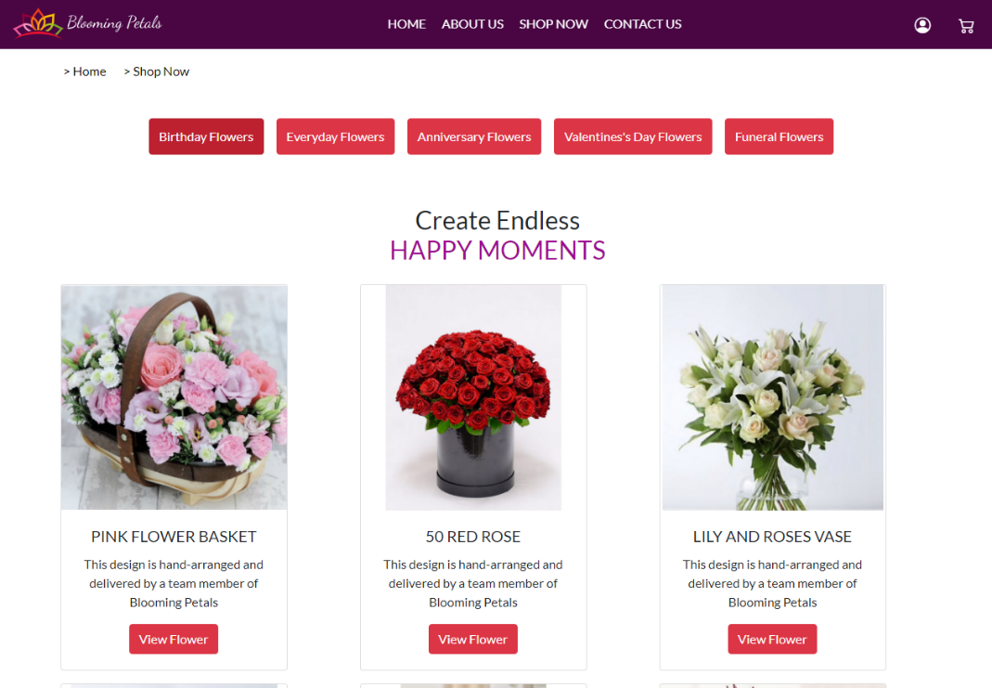

**Birthday**

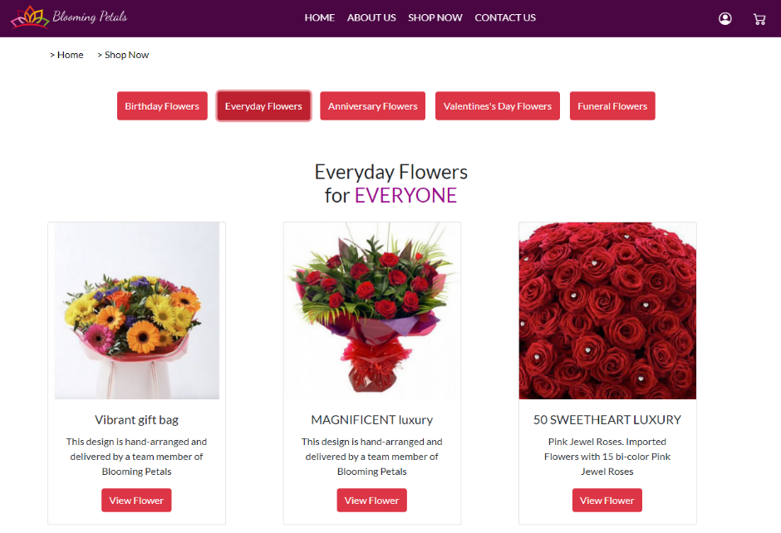

**Everyday**

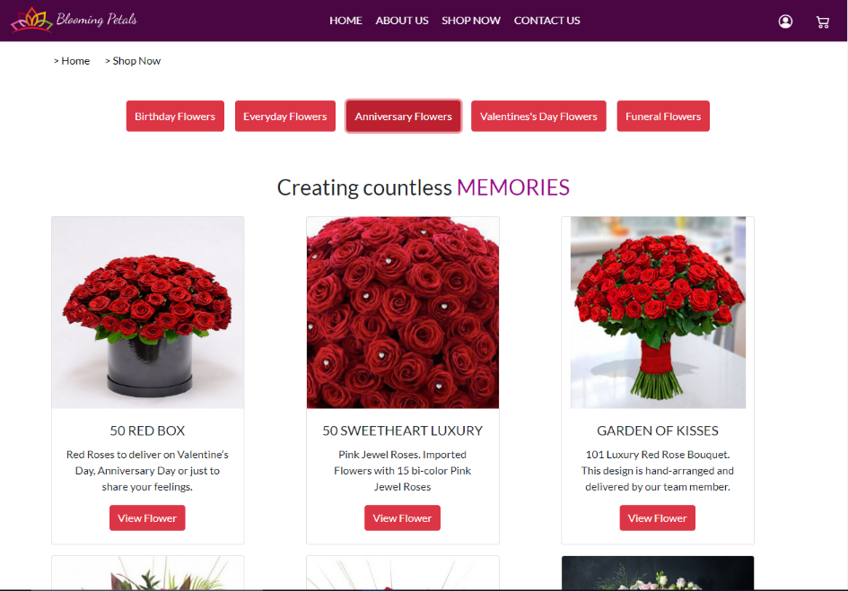

**Anniversary**

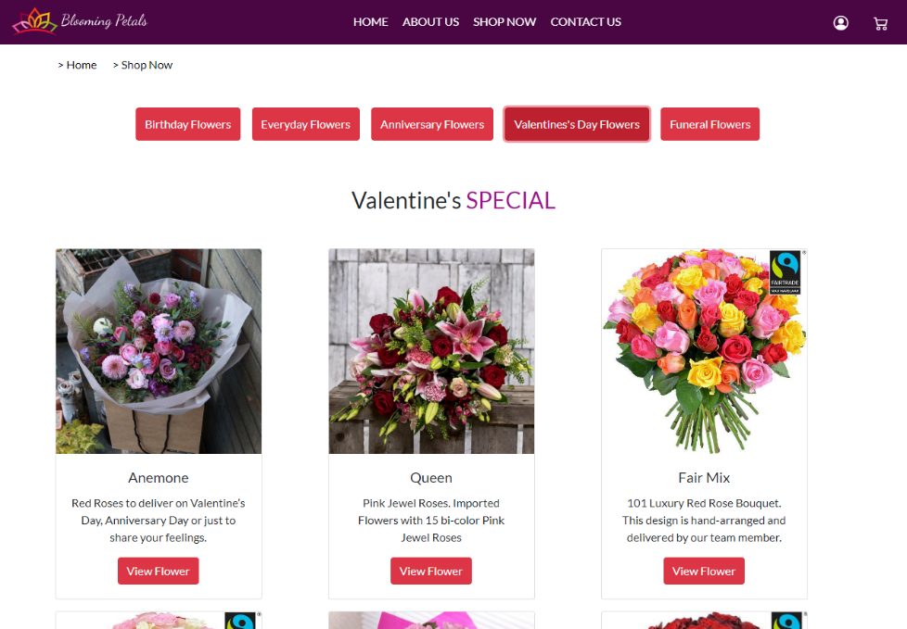

**Valentine’s**

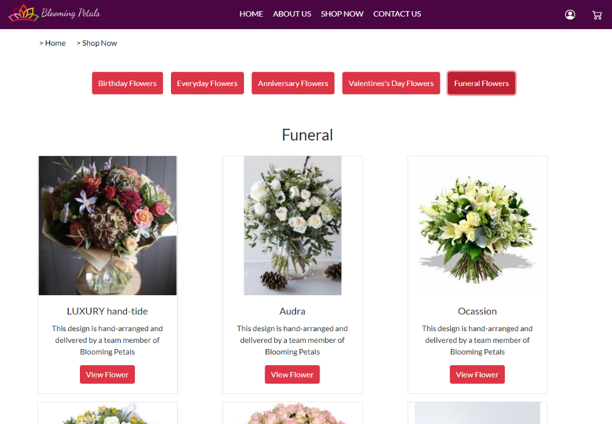

**Funeral**

**Product Pages**

***~ By Flower Types***

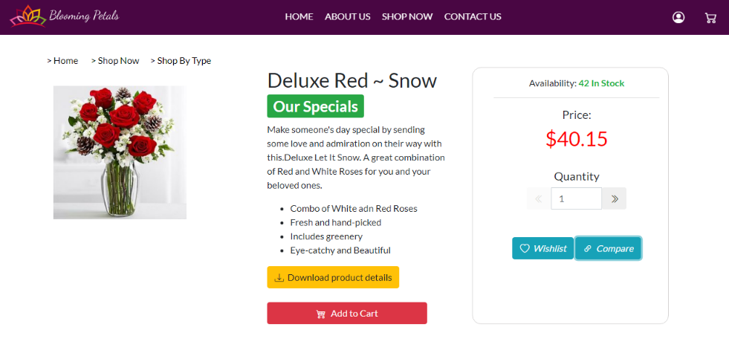

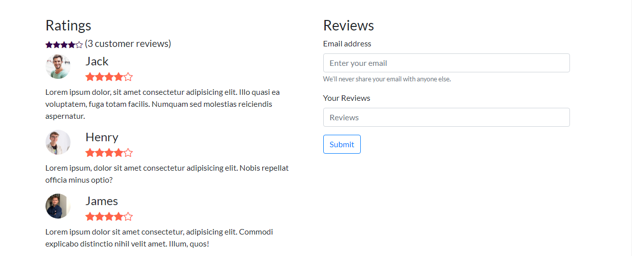

**Roses**

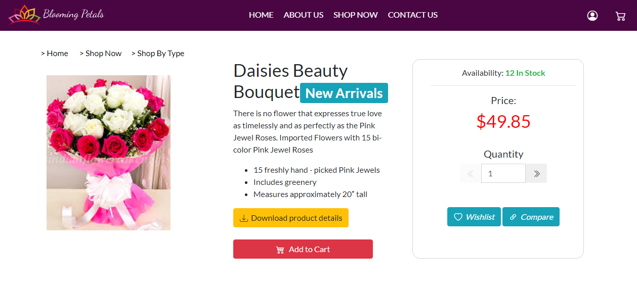

**Daisies**

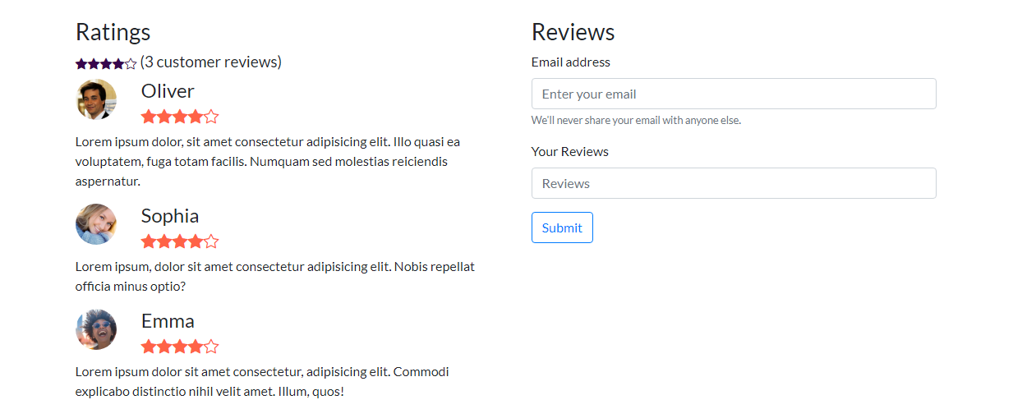

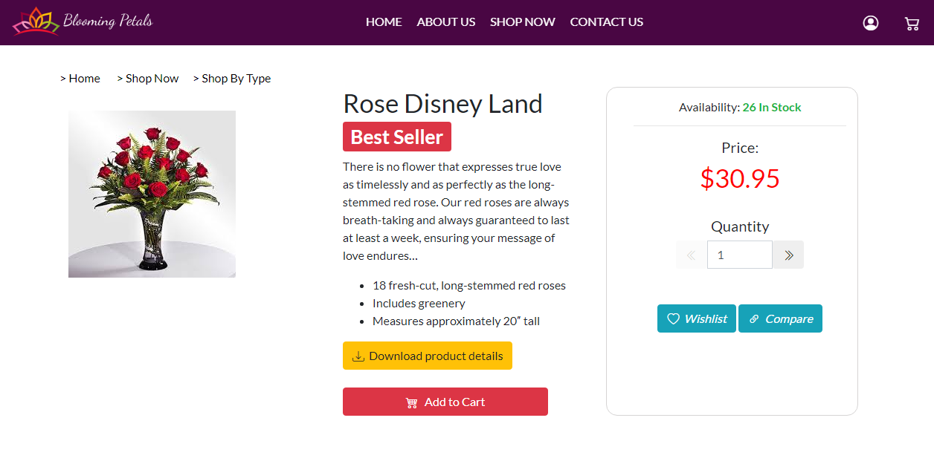

**Tulips**

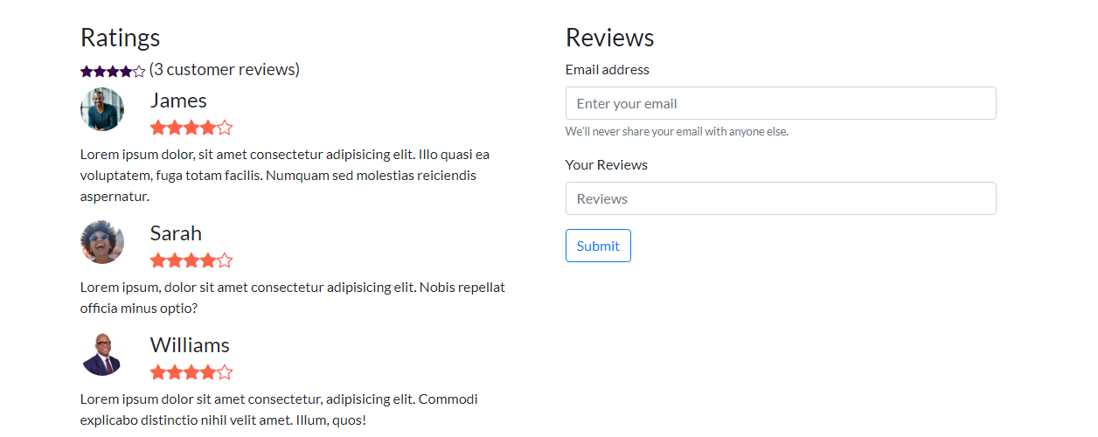

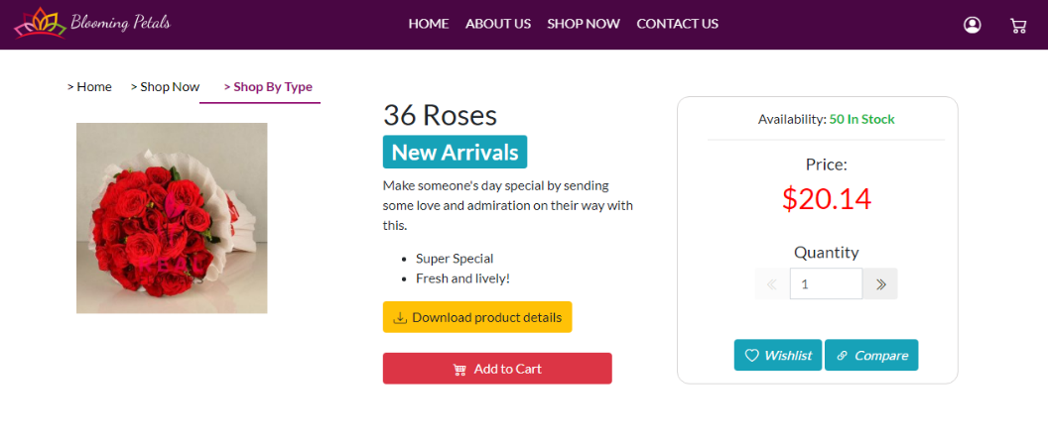

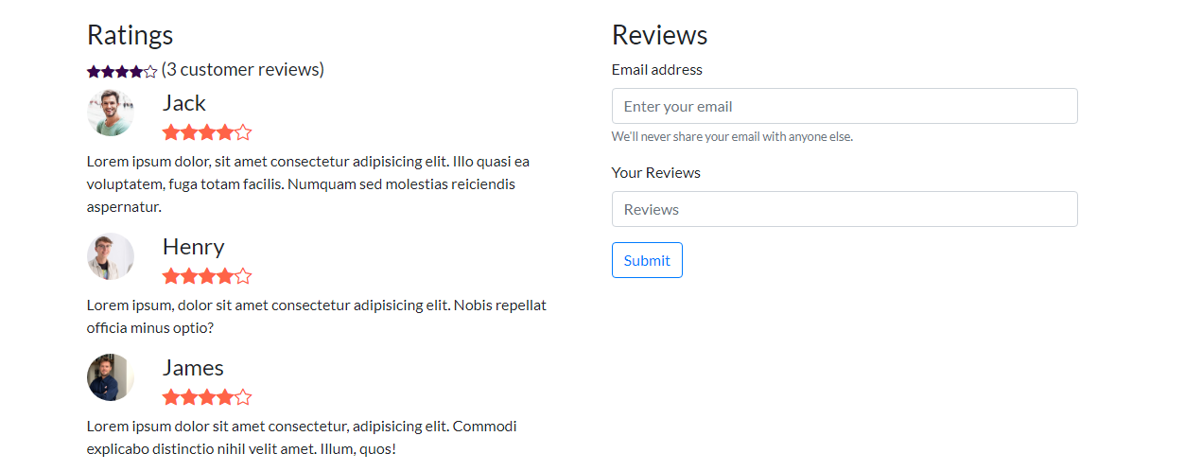

**Dhahliya**

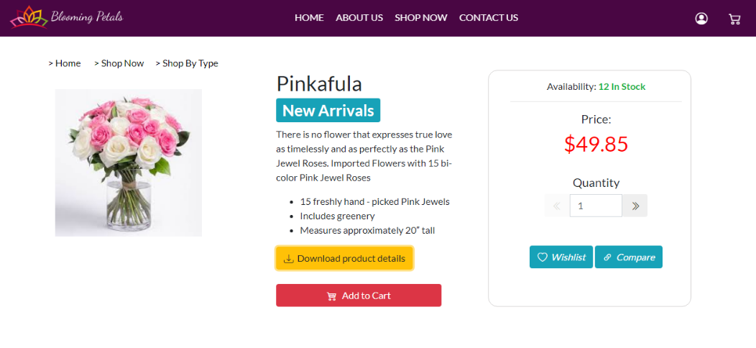

**Peonies**

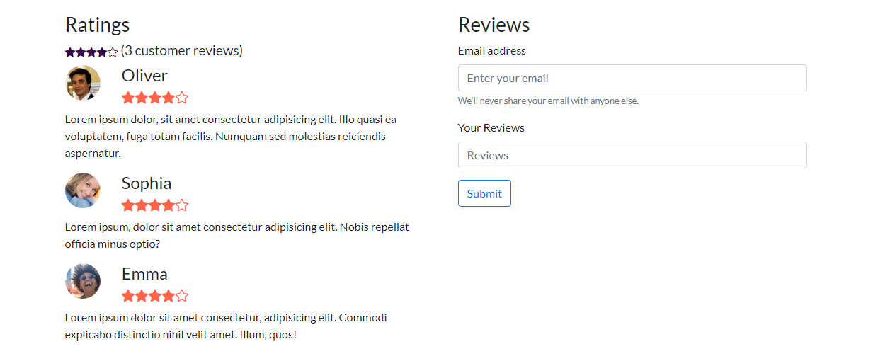

**Product Pages**

***~ By Occasions***

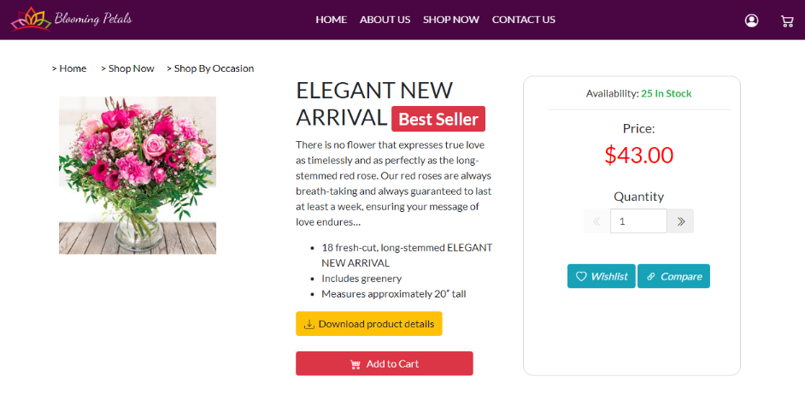

**Birthday**



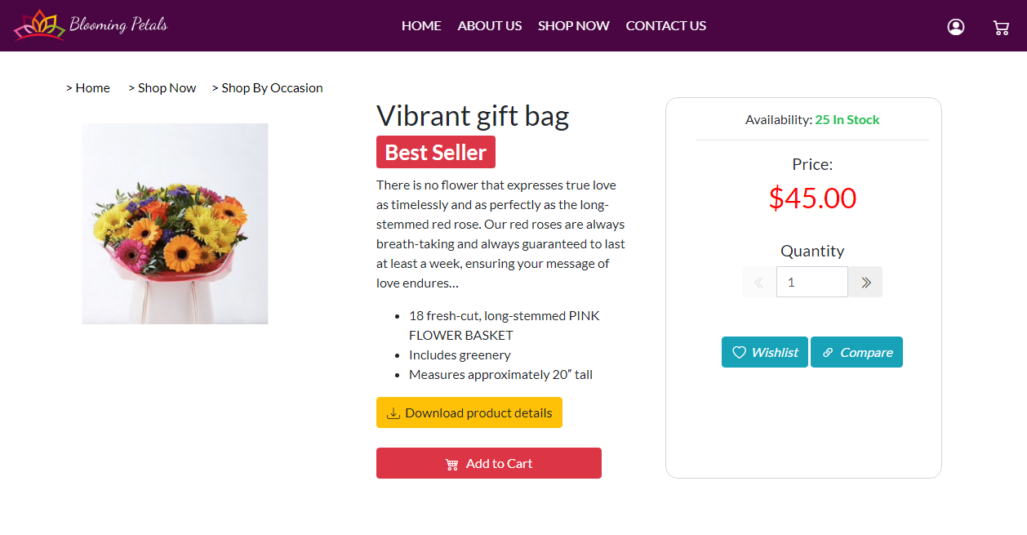

**Everyday**



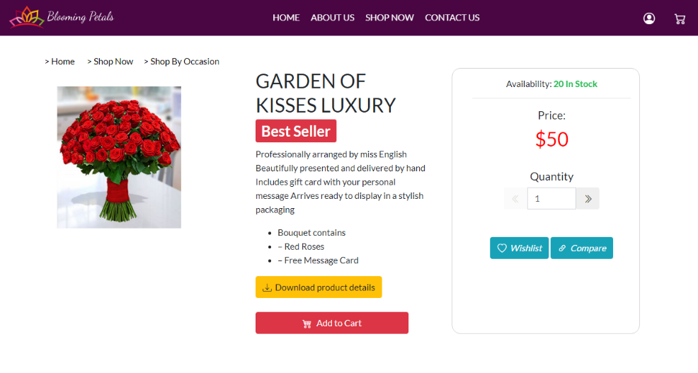



**Anniversary**

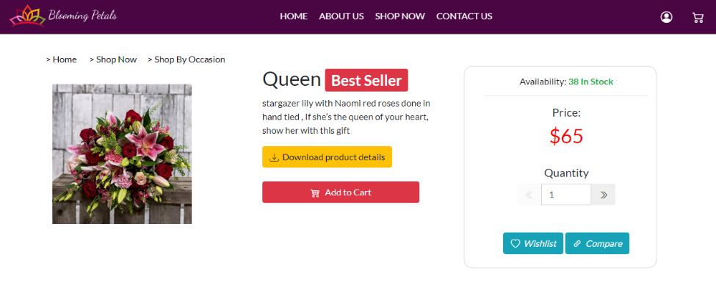

**Valentine’s**



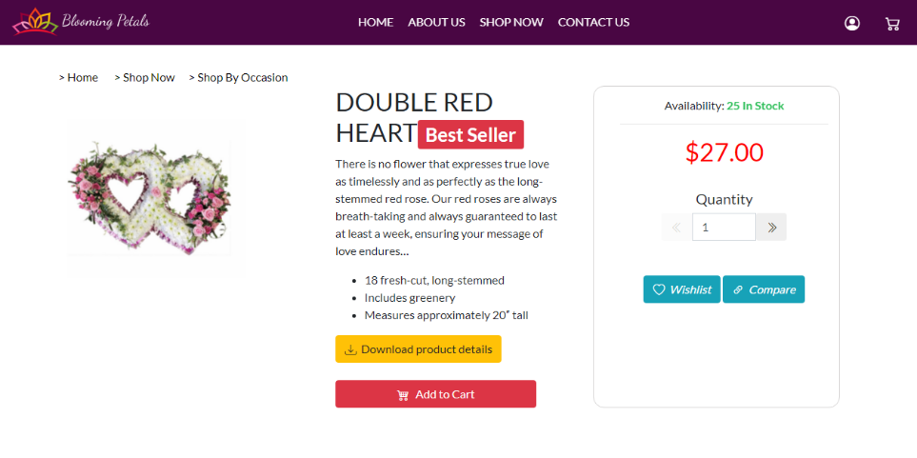

**Funeral**



**Task Sheet**

|  |  |  |
| --- | --- | --- |
| Enrollment No | Student Name | Role |
| * Std. Id 1298356 | Safwan Ahmed | Analysis, Coding, Design, Testing & Documentation |
| * Std. Id 1285860 | Khawaja Ali Nazar | Coding & Design |
| * Std. Id 1298047 | Tariq Riaz | Coding & Design |
| * Std. Id 1298367 | Muhammad Umer Farooqui | Coding & Design |
| * Std. Id 1298099 | Abdi Habib | PDF Design |

**Project Title: Blooming Petals**

|  |  |  |  |  |  |
| --- | --- | --- | --- | --- | --- |
| Project Ref. No. | | Date of Preparation of Activity Plan | | | |
| S# | Task | Activity Plan Prepared By | Actual Start Date | Approx. End Date | **Status** |
| 01 | Analysis | Safwan Ahmed | 03/3 | 23/3 |  |
| 02 | Design | Safwan Ahmed | 05/03 | 21/3 |  |
| 03 | Coding | Team Work | 05/03 | 21/3 |  |
| 04 | Testing | Team Work | 22/3 | 23/3 |  |
| 05 | Documentation | Safwan Ahmed | 22/3 | 23/3 |  |

**THANK YOU!**

